2.95: For convenience, let the student's (constant) speed be v₀ and the bus's initial position be x₀. Note that these quantities are for separate objects, the student and the bus. The initial position of the student is taken to be zero, and the initial velocity of the bus is taken to be zero. The positions of the student x₁ and the bus x₂ as functions of time are then
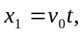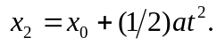

a) Setting 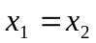and solving for the times t gives

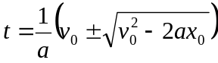
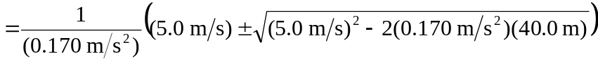
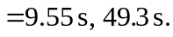

The student will be likely to hop on the bus the first time she passes it (see part (d) for a discussion of the later time). During this time, the student has run a distance 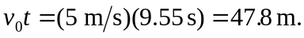

b) The speed of the bus is 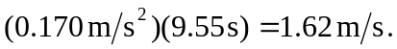

c) The results can be verified by noting that the x lines for the student and the bus intersect at two points:

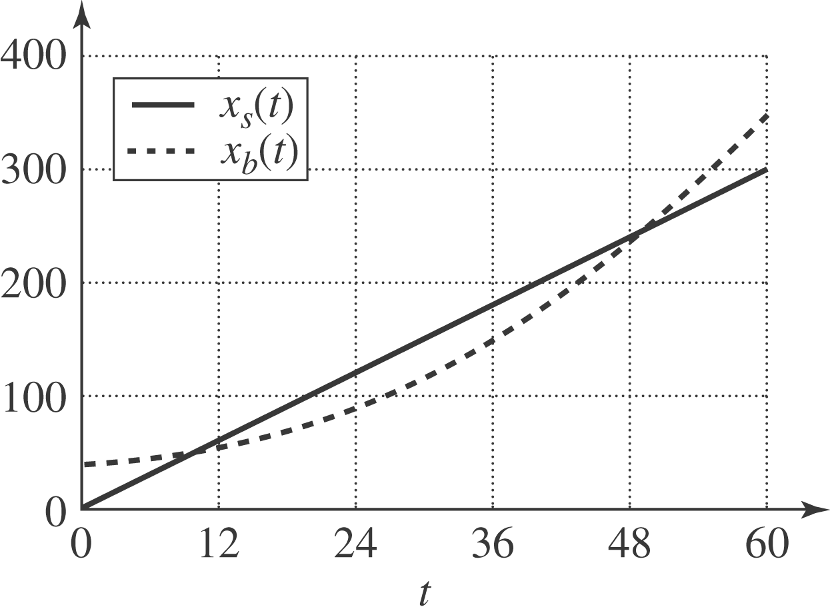

d) At the later time, the student has passed the bus, maintaining her constant speed, but the accelerating bus then catches up to her. At this later time the bus's velocity is 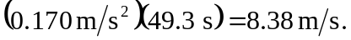

e) No; 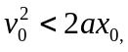 and the roots of the quadratic are imaginary. When the student runs at 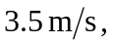, the two lines do not intersect:

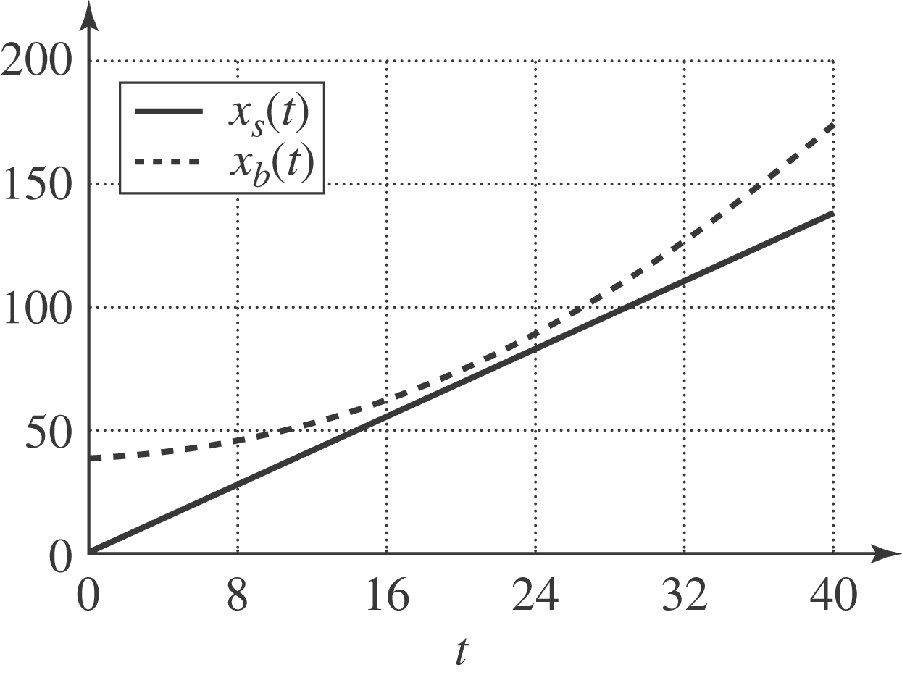

f) For the student to catch the bus, 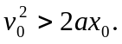 and so the minimum speed is 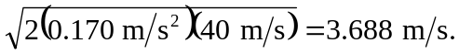 She would be running for a time 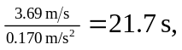and cover a distance 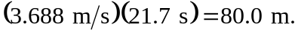
However, when the student runs at 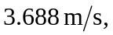the lines intersect at one point
(x = 80 m).
